## horizontal line

Loss Functions

20.01.2025

# Loss Functions

Loss Function is a method of evaluating how well your algorithm is modelling your dataset .

It is a measure which you can improve by updating your weights.



Loss function vs Cost function :

Loss function is for simple row by row in a dataset while Cost function is for overall dataset.

## Mean Squared Error

Also called as squared or L2 loss.

Mse = (yi - yi_hat)^2

Cost Function : 1/n $\sum_{i=0}^{n}{}$ (yi - yi_hat)^2

| Advantages | Disadvantages |
| --- | --- |
| Easy to interpret | Error unit (squared) |
| Differentiable (GD) | Not robust to outliers |
| 1 local minima |  |

## Mean Absolute error

Also called L1 loss

mae = |yi - yi_hat|

Cost Function : 1/n |yi - yi_hat|

| Advantages | Disadvantages |
| --- | --- |
| Intuitive and easy | Not differentiable |
| Unit same |  |
| Robust to outliers |  |

## Huber loss

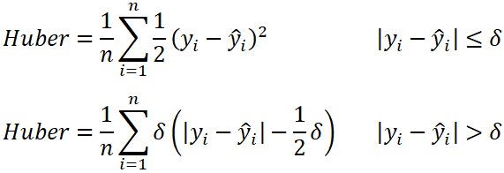

Huber loss acts as mae if data have outliers otherwise mse . It works well when data has many outliers.

## Binary Cross Entropy

Used for classification when there are 2 classes . Also called log loss .

Bce = -y log(y_hat) - (1-y) log (1-y_hat)

Cost func = -1/n [ $\sum_{i=1}^{n}{}$ yi log (yi_hat) + (1-yi) log (1-yi_hat) ]

| cgpa | iq | placement | yi_hat |
| --- | --- | --- | --- |
| 8 | 80 | 1 | 0.73 |
| 7 | 70 | 0 | 0.25 |
| 6 | 60 | 0 | 0.40 |

Last node Activation function is sigmoid.

| Adv | Disadv. |
| --- | --- |
| Differentiable | Multi local minima |
|  | Intuitive |

## Categorical Cross Entropy

Used in softmax regression. Multi class classification.

L = - $\sum_{i=1}^{k}{}$ yi log (yi_hat) where k is no. of classes.

Last node activation function softmax.

| cgpa | iq | placed | Yes | No | Maybe | yi_hat |
| --- | --- | --- | --- | --- | --- | --- |
| 8 | 80 | yes | 1 | 0 | 0 | 0.2 , 0.3 , 0.5 |
| 6 | 60 | no | 0 | 1 | 0 | 0.1, 0.5, 0.4 |
| 7 | 70 | maybe | 0 | 0 | 1 | 0.2 , 0.3 , 0.5 |

## Sparse Categorical Cross Entropy

Same as cce but here One hot encoding is in integers . In that case y will be taken as 1.

Sce = - yi log (yi_hat)